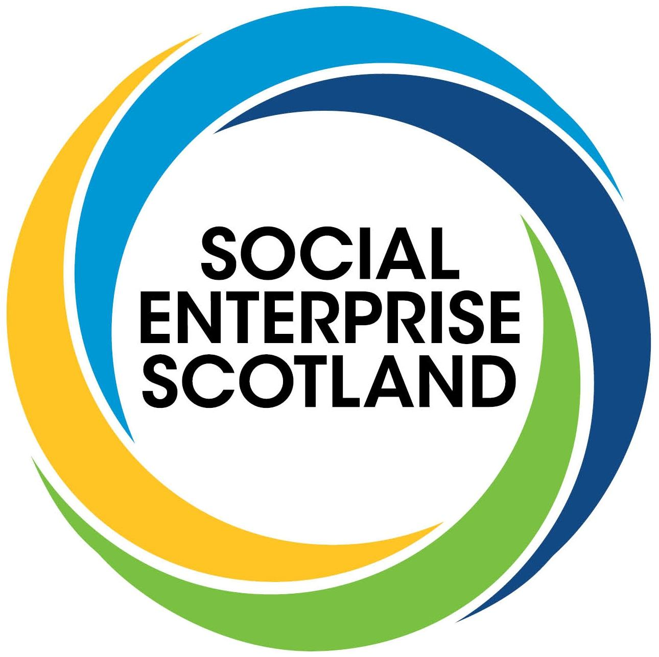

The development of the National Strategy For Economic Transformation: a response from representatives of Scotland’s social enterprise community

Introduction

We welcome the opportunity to contribute to this consultation and the ongoing conversation around building a better economy. We have consulted with grassroots social enterprises and support bodies in order to inform our response.

The purpose of social enterprises is to create genuine economic transformation. This key objective can’t be achieved unless social enterprises, other values and mission-led businesses and third sector organisations are at the centre of the 10 year strategy.

In every community in Scotland social enterprises are at the forefront of people-led responses to build local, sustainable economies and inclusive employment. Social entrepreneurs are driven by their social mission.

During the pandemic lockdown it was social enterprises, charities, community groups and other third sector organisations that led the way when statutory services and private sector businesses were often unable to operate. From tackling food poverty to housing, child and adult care, mental health and much more.

The Scottish Government has stated their commitment to social enterprises being at the vanguard of economic transformation.

The key Scottish Government report, published in June 2020, Towards a Robust, Resilient Wellbeing Economy for Scotland: Report of the Advisory Group on Economic Recovery, says that the third sector:

“will be just as important in the period of economic recovery, supporting young people, employability, health and wellbeing...we think that it is essential to put the third sector at the heart of planning for recovery and renewal, recognising its critical contribution to the goal of a wellbeing economy in Scotland”, adding: “And while many of our recommendations are directed at the Scottish Government and its agencies, businesses, the third sector and other organisations all have an essential role to play in securing the recovery Scotland needs.”

On Page 1 of the latest Social Enterprise Action Plan, published in March 2021, it says:

“Scotland's renewal must be rooted in fairness and equality. Social enterprises will be central to this work, because they point to an approach that helps us rebalance our economy and enables us to translate our aspirations around creating a wellbeing economy into a reality.”

It adds: “Social enterprises demonstrate how Scotland's businesses can help us work towards a modern wellbeing economy through prioritising sustainable growth, environmental responsibility, promoting fair work, inclusion and opportunities for all...they point to an approach that helps us rebalance our economy and enables us to translate our aspirations around creating a wellbeing economy into a reality.”

In the Stakeholder Recovery Roundtable in May this year there were many more encouraging words from Ministers, including The Cabinet Secretary for Finance and the Economy who noted her three priorities: “protecting the economy; working across boundaries to protect employment as part of a national endeavour for economic recovery; and longer term economic transformation.”

We also support the Vision of Scotland’s first Citizens’ Assembly that applies to economic policy-making:

“The Scotland we want to see should lead with integrity, honesty, humility and transparency, in a self-sufficient and innovative way, and actively include the people of Scotland in decision making.”

Social enterprises must be empowered to help lead the way to a new economy over the course of the next decade. It is social enterprises, third sector organisations and other values-led businesses that have many of the bold ideas to drive transformation.

The economic impact of Scotland’s social enterprises

Social enterprises, charities and community and voluntary groups make a significant economic contribution to Scotland. They must be included in all government economic policy-making.

Social enterprises are at the heart of communities and more connected to those who most need the economy to be transformed. They have a greater understanding of what really needs to change from a pragmatic, lived experience point of view.

Social enterprise ensures the sustainability of communities, particularly in a rural and island context, responding to market failure and delivering vital services such as housing, shops and fuel filling stations.

A large number of social enterprises are comparably modest in size but when they’re enabled as a collective they make a significant combined contribution to economic transformation.

There are over 6,000 social enterprises in Scotland, with over 40,000+ organisations that form the larger social economy, including around 25,000 registered charities.

According to the Social Enterprise Census 2019, the following key economic statistics evidence the clear value of social enterprises to Scotland’s economy.

Please note: the next Social Enterprise Census is due to be released at the end of 2021 where we will see more current data regarding the status of the social enterprise community, in particular the impact of the past 18 months of the pandemic lockdown period.

- 6,025 social enterprises operating in Scotland.
- 88,318 Full-time equivalent employees in the sector.
- £2.3bn Gross Value Added (GVA) to the Scottish economy.
- 33% of social enterprises are located in rural Scotland (with just 17% of the population).
- 75% of social enterprises pay at least the living wage to all employees.
- £6.1bn is the net worth of Scotland’s social enterprises.

The social enterprise sector is large and growing. Total income has reached £4.37 billion, a healthy increase of 15% since 2017 and 22% since 2015.

The membership of the Scottish Government Economic Advisory Council

We welcome the commitment to a bold and ambitious vision to change economic systems, values and beliefs.

While we recognise and appreciate the particular strengths of individual Council members, the new Council has limited reach and scope and is not a partnership that includes all key players in the economy.

Despite the vital economic contribution of social enterprises and other progressive business models, charities and community groups, they have largely not been included in the membership of the Council. In addition the exclusion of climate experts seems to have been forgotten, as Scotland seeks to achieve net zero and a green recovery.

We’re disappointed that this has happened and we would welcome further clarity as to how our organisations can directly influence economic strategy through the Council.

We don’t believe there’s been enough time for organisations and individuals to consider these issues in-depth, particularly over a summer recess period, and in the context of creating a 10 year strategy for fundamental change.

We faced a similar situation with the exclusion of social enterprise and third sector organisations at the foundation of the Scottish National Investment Bank (SNIB).

This was seemingly remedied after much work by SCVO, supported by Social Enterprise Scotland. It remains to be seen whether the SNIB will now invest in third sector development in a meaningful way, as to date no investments have been made into third sector organisations.

The vision, principles and values of the Council need to be anchored in delivering human and ecological wellbeing for people and planet. Traditional private sector interests should of course be represented but this shouldn’t be to the exclusion of social enterprises and the third sector.

The Care Review, for example, took a different approach to this kind of strategic plan, particularly when it came to handing power to those who would most benefit from change. Any significant policy process like this must find ways to meaningfully and creatively involve people from all walks of life so that policy is led by the people it affects most.

Previous reports and consultations around the economy, social enterprise and the third sector

As well as the reports previously mentioned in this consultation response we would also refer you to the many previous consultations and reports that have looked at economic development, the wellbeing economy, social enterprise, the third sector and post-lockdown recovery.

Reference has recently been made in the sector to reports as far back as the Christie Commission on the future delivery of public services, published in June 2011, with public service ambitions that have yet to be fully realised.

We believe that there is much to learn from these initiatives and reports over the past few years that have not yet been translated into tangible public policy:

- If not now, when? - Social Renewal Advisory Board report

- Open letter - bring forward a Wellbeing and Sustainable Development (Scotland) Bill - Scotland's Sustainable Development Goals Network (globalgoals.scot)

- Green Recovery Inquiry - Report from The Environment, Climate Change and Land Reform Committee

- State of the Sector Report – COVID-19 and the impact on Social Enterprise in Scotland

Policy priorities relevant to economic transformation and social enterprise

The work of social enterprises is already impacting on many Scottish Government priorities in a wide variety of economic policy areas.

Net zero and climate change

The social enterprise community has produced key commitments to tackling the climate emergency within the context of an inclusive, wellbeing economy.

A sector steering group has been focused on raising the profile of climate change impacts within our sector, surveying organisations and exploring the key role of social enterprises in this agenda. This includes involvement at COP26 and raising the profile of green social enterprises.

Social enterprises that work directly in environmental services, providing green jobs, contribute £41.0m GVA, according to Census 2019.

Social enterprises, employment and fair work

Employment is a fundamental aspect of mental health and wellbeing. In the context of much job dissatisfaction and productivity challenges, social enterprises seek to provide meaningful work.

Social enterprises employ 88,318 full-time equivalent employees, according to Census 2019. However, this is only part of the picture. Our organisations, particularly social firms, specialise in meaningful employment and employability for those furthest from the job market i.e. young people, disabled people, ex-offenders and other excluded groups.

Social enterprises are key drivers in the fair work and equalities agendas. 75% of social enterprises pay at least the living wage to all employees and 65% of social enterprises are led by women.

In addition 81% of social enterprises involve employees formally in decision-making, according to Census 2019. Many social enterprise businesses pro-actively seek out involvement in key initiatives such as Fair Start Scotland and the Young Person’s Guarantee.

As a result of the pandemic lockdown many social enterprises have innovated and switched services online, from e-commerce platforms to digital services and online sports and mental health support.

Community Wealth Building and regeneration

Community-owned and managed Development Trusts and similar social enterprise models are focused on the varied needs of their local community. There are around 300 development trusts in Scotland.

They combine enterprise and innovation to improve lives and are involved in renewable energy projects, housing, food growing and a wide range of other activities that renew and drive local economies. They are a key solution as policy-makers seek to develop community wealth building.

Indeed all social enterprises develop and grow economic responses at a local level and are ideally placed to help drive forward the Community Wealth Building agenda, acting as community anchors. This very much includes the need for more public procurement opportunities and public service delivery.

The recent Scottish Government announcement around a Minimum Income Guarantee is a significant additional step towards reducing poverty and building wealth within our local communities.

Conclusion

We don’t believe that a traditional “business as usual” approach can work in driving economic transformation and building a genuine wellbeing economy.

Certainly we need a cross-sectoral approach, working in partnership with others across the third, public and private sectors. Without this approach we won’t be able to build an inclusive economy.

We ask that the membership of the Council is reviewed to ensure that its remit can be fulfilled and that it includes social enterprises, other progressive businesses, third sector organisations and community groups. This approach should be mainstreamed across all economic policy initiatives.

Existing pledges on e.g. Community Wealth Building, social investment, a green recovery, social enterprise development and fair work must be joined up and mainstreamed within economic policy. These should be harnessed together in order to unleash social entrepreneurship and economic resilience.

Evidence based and data driven policy needs to include a shift away from solely economic based indicators and towards a more holistic approach that captures social enterprise economic activity. Tools like the National Performance Framework can be further developed.

In addition the use of existing devolved powers e.g. on taxation are currently underutilised and could be better harnessed in order to achieve this joint agenda.

We strongly believe in positive economic transformation that directly benefits both people and planet. Social enterprises and third sector organisations must be at the forefront of this change.

Acknowledgements

This consultation response was possible as a result of the valuable contributions of the Social Enterprise Scotland steering group for economic transformation, social enterprises and other partners:

Alex Stobart, Mydex CIC and Social Enterprise Scotland
Angela Moohan, The Larder
Alastair Davis, Social Investment Scotland
Ailsa Clark, InspirAlba
Linda White, West Lothian Social Enterprise Network

Social Enterprise Scotland is an independent, Scottish, membership-led organisation, built and controlled by social enterprises. We’re the first point of contact for the media and public and promote a positive vision for social enterprise. We pro-actively engage with our social enterprise partners, the public sector, the media, the private sector and the wider public. We work in partnership with many other organisations in and outwith the broad social enterprise movement, with The Scottish Government and Parliament and local authorities.

Ref: DTSES210819

END

---------------------------------------------------------------------------------------------------------------

